อักษรย่อกระบวนวิชา | 331507
ชื่อ สกุล
ชนิดข้อสอบ | MCQ
ระดับข้อสอบ
เกณฑ์แพทยสภา
ข้อความตามเกณฑ์
แหล่งอ้างอิง

A 45-year-old male had minimal back pain for 5 years. Two weeks before seeing the physician, he developed sudden, severe additional pain radiating to the medial aspect of left leg. Physical examination revealed diminished sensation around the left medial malleolus, otherwise normal. Imaging studies showed as figures. What is the most appropriate management in the patient?
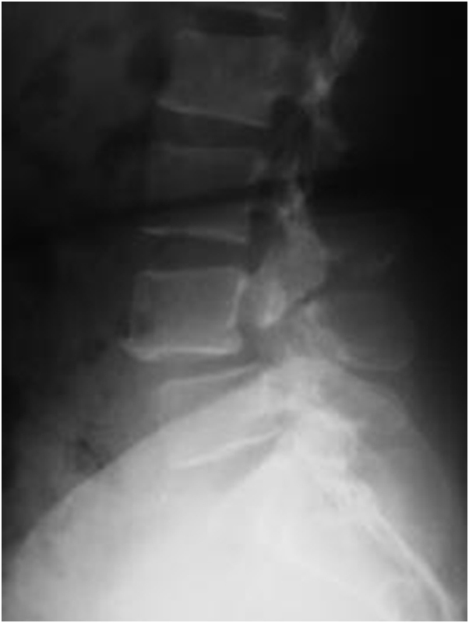
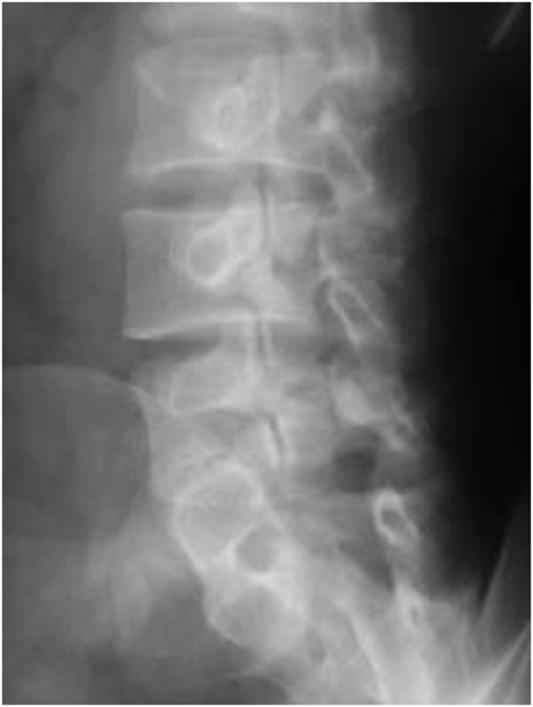
A | MRI Lumbosacral spine
B | Rest, back support, analgesics medication
C | Quadriceps strengthening exercise (left)
D | Screw fixation through L4 pars interarticularis
E | Decompressive laminectomy & L4-5 fusion

CORRECT ANSWER | B

KEYWORD

